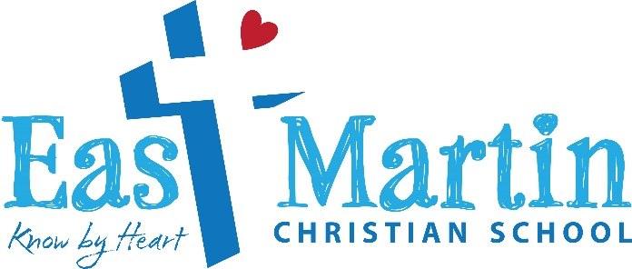

Faith Statement
At East Martin Christian School, we believe and teach that God is Creator and Sustainer of all things. His original creation was perfect and without sin, but mankind having been given his own free will, disobeyed God and thus severed the relationship between God and mankind. Desiring to reconcile mankind to Himself, God demonstrated His great love for us by sending His Son, Jesus Christ, to live a perfect, sinless life here on earth. Jesus willingly sacrificed His own life in order to take the punishment we deserved from God upon Himself. By believing in Jesus’ death and resurrection from the dead we can seek forgiveness from God for our sinfulness, and one day, by God’s grace, be called to live with God and believers from all ages for eternity.
At East Martin Christian School we believe and teach that God has given us His Word, the Bible, so we may better understand Him and study the redemptive history He has laid out from the beginning of time. The Bible is infallible and teaches us how to live before God and among all His creation. God intentionally created us, either male or female, to be relational both with Himself and others, and instituted a family order that dictates that one man and one woman shall commit to one another and become one flesh. Children are to be taught the morals of God described to us in His Word and thus be equipped to live a life that honors Him.
…………………………………………………………………………………………………………………………………………………
In enrolling our child(ren) at East Martin Christian School, we agree to support the school, understanding that the school teaches all subjects based on the Word of God and the faith statement above. We agree not to participate in any activity with the purpose of expressing disagreement with the faith statement nor make any public statements that undermine the faith practices of East Martin Christian School.

__________________________________________________________ _________________________________
Parent signature Date

_________________________________________________________________________ _________________________________________
Parent Signature Date

